LAB 6: SMALL-SIGNAL AMPLIFIER

# Goals

* + Understand the working principle of a bipolar BJT.
  + Build up and analyze a small-signal amplifying circuit using a BJT.

**Nhóm 1 ICT-02**: Nguyễn Đức Anh

Phạm Đức Cường

Bùi Tuấn Đạt

Nguyễn Tuấn Đức

**Exercise 1.** Implement and analyze the small-signal common-emitter amplifier as shown in Figure 1.

# Requirements:

* + **Implement the circuit on a breadboard with: R1 = 47 kΩ; R2 = 12.5 kΩ; RC = 1 kΩ;**

**RE = 330 Ω; C1 = C2 = 0.1 µF, CE = 22 nF; β = 300; VBE (on) = 0.7 V.**

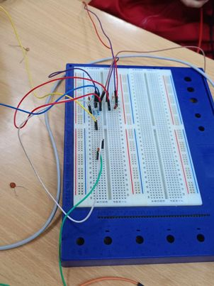

* + Use a pulse generator to provide the input signal Vin = V0sin(2π*ft*), with V0 = 0.5 ~ 1 V and *f* = 1 kHz. Use a DC power supply to provide VCC = 10 V.

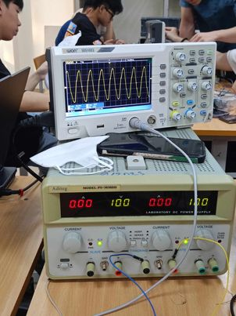

VCC



R1

RC

C2

C1

B C

E

~–

+

R2

R

E

C

E

Vout

Vin

*Figure 1. Small-signal common-emitter amplifier.*

* + Use a multimeter to measure the *Base* (IB) and *Collector* (IC) currents of the transistor. Compute the common-emitter current gain β of the transistor.
* Base: IB = 0.35 $μ$ A
* Collector: IC = 92.53 * 10-3 mA
* β = 272

**Comment:** Ib is usually very small compared to Ic in transistor BJT. The ratio Ic/Ib is the amplification coefficient, which represents the ability to amplify the current of the transistor.

- If β is different from the theoratical figure it may due to errors in transistor manufacturing process or the influence of temperature and polarization voltage.

* + Use an oscilloscope to display the input voltage (Vin) and the output voltage (Vout) of the circuit. Based on the input/output voltage waveforms shown on the oscilloscope, determine the *voltage gain* (Vout/Vin) of the circuit. Compare the measured result with the theoretical calculation.
* Vin:

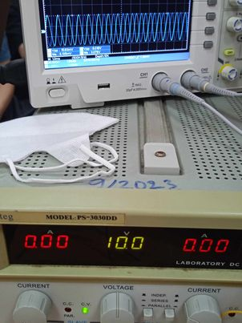

* Vout:

* Voltage gain: - Vout / Vin = - 2.2
* Comparison of results with theory: The measured results closely resemble the theoretical calculations. The slight differences between experimental and theoretical values can be attributed to both systematic errors originating from the measuring equipment used and random errors.
  + Set RC = 2 kΩ and keep the values of the other components unchanged (Vin is also unchanged). Use the oscilloscope to observe the output voltage waveform of the circuit. Comment on the waveform of the output voltage.
* Comment: When the value of RC changes, the operating point Q will also change accordingly. To maintain stable operation of the circuit, it is necessary to adjust the bias point of the transistor by changing R1 and R2.
* Draw some conclusions about the output voltage waveform:

The output wave form is distorted in peak.

* Give your explanation:

The reason is Rc. increasing but IB remain unchanged (IR doesn't depend on Rc but depends on Re, R1, R2, β). Rc increase so the current through transistor also increase, so the amplification coeffiecient also increases. This means Vout will larger than Vin. The output signal amplitude will be limited by the power supply and the value of Rc. As Rc increases, the output signal amplitude can approach the maximum limit of the power supply. However, the output voltage cannot exceed the power supply. Harmonic distortion: As the value of Rc increases, harmonic distortion may decrease. Harmonic distortion is the unwanted phenomenon of distortion of the output signal compared to the original input signal. By increasing Rc, harmonic distortion can be reduced, and the quality of signal amplification can be improved.

Ic remain unchanged.

* + So VRC increase (as RC increase)
  + VCE will decrease (Kirchoff VCE will decrease to a certain value and the saturation)
  + With RC = 2 kΩ, compute the values of R1 and R2 again to make sure that the input voltage waveform and the output voltage waveform are similar, i.e., the input and output voltages have a sinusoidal waveform (no distortion), but they are out of phase. Besides, the voltage gain of the circuit should be aligned with the theoretical calculation.

$$I_{CQ}=\frac{V_{CC}-V_{CEQ}}{R_{C}+R_{E}}=\frac{10-5}{2000+330}=2.146\left(mA\right)V_{RE}={2,146.10}^{-3}.330=0,70818V{ so I}_{BQ}=\frac{I_{CQ}}{β}=\frac{{2,146.10}^{-3}}{300}=7,153\left(μA\right){ and we have I}_{BQ}=\frac{V_{TH}-V_{BE\left(on\right)}}{R_{TH}+\left(1+β\right)R_{E}}R_{TH}=0,1\left(1+β \right)R_{E}=9,933\left(kΩ\right)$$

We have: $V_{BE}\left(on\right)=0,7V$

$$⇒V_{TH}=1,481\left(V\right)=\frac{R_{2}}{R_{1}+R_{2}}{ V}_{CC}⇒\frac{R_{2}}{R_{1}+R_{2}}=\frac{1,481}{10}=0,1481$$

We have:

$$R_{TH}=\frac{R_{1}R_{2}}{R_{1}+R_{2}}={9,933.10}^{3}⇒\{R_{1}=67,544\left(kΩ\right) R_{2}=11,645 (kΩ)$$

**Components and devices needed for the lab:**

|  |  |  |
| --- | --- | --- |
| **Components and Devices** | **Description** | **Amount** |
| BJT | 2N3904 or 2N2222, 50V-1A | 1 |
| Resistor | 330 Ω / 2 kΩ / 2.5kΩ / 10 kΩ / 47 kΩ | 1/1/1/1/1 |
| Ceramic capacitor | 0.1µF, 22 nF | 3 |
| DC power supply | Aditeg PS-3030DD | 1 |
| Pulse generator | UNI-T UTC962E | 1 |
| Oscilloscope | OWON SDS1102 | 1 |
| Breadboard | | 1 |
| Wire | | Few |
| Multimeter | | 1 |